SESSIÓ D’EDUCACIÓ FÍSICA

ALUMNES: Paula Osorio i Irene Sandín  CURS: 4 ESO B  ESPORT: Pilates | MATERIAL:  Mats | OBJECTIUS:  Get flexibility and balance
INICI
Temps | Nom activitat i explicació
5 min | 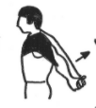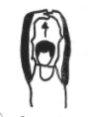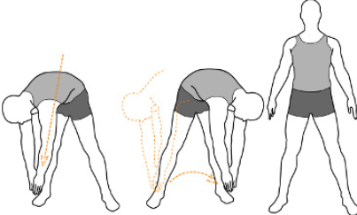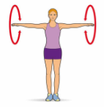  All the exercices are to prepare the muscles easly.

Part principal
Temps | Nom activitat i explicació | Representació Gràfica
15min | Put like in the photo and your butt up and down.  put your one side on the floor and the leg that’s up go up and down, and the change side and do the same with the other leg.  keep the balance and go up and down  Again, dog position and up and down your leg in 90 degree  (change the leg)  Your back in the floor and get one leg after another.  swimmers exercicies  Dog position and up and down straight leg (change the leg)  In pairs, put your feets together but with the legs closed and strech | 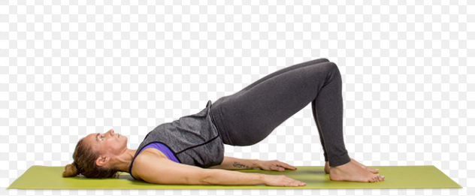  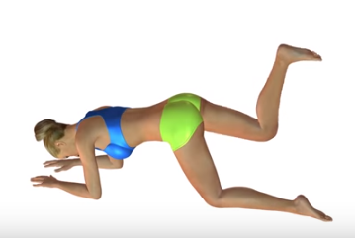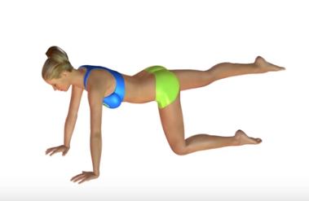  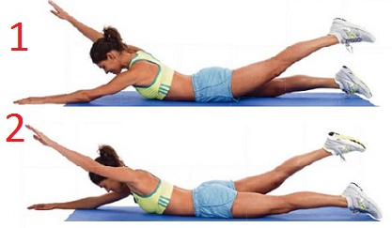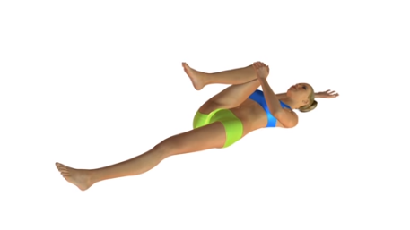  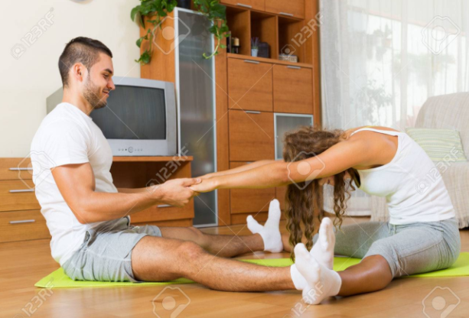

FINAL
Temps | Tipus d’activitat
3 min | 